The Edmodo Guide

Edmodo.com

1. Teacher Sign Up
Step 1: Click the Teacher Signup link on Edmodo.com
Step 2: Fill out the sign-up form
Congratulations: Now it's time to create your first group.

2. Create a Group
Step 1: Click the create link
Step 2: Enter the name of the group/class you want to create. TIP: Group names must be unique to you in some way. Many generic names such as Biology are already taken.
Step 3: Once your group is created you will get a message at the top saying your group name has been created. You now see your group in the left sidebar of Edmodo. You will also be messaged your group code that you give to students to sign up for edmodo. They will automatically be signed up for your group if they use your code to sign up for edmodo. If any of your students already have an Edmodo account from a previous class they can login and click the join link and enter the code you give them.
Congratulations on creating your first group. Now it's time for your students to sign up with the group code that was just generated.

3. Student Sign Up
Step 1: Click the Student sign-up link on the Edmodo homepage.
Step 2: Enter the sign-up code that was given to you by your teacher and Fill out the student sign-up form. Student e-mail address's are optional and not required for students.
Step 3: You should now be signed up for your teacher's Edmodo group and ready to start posting in Edmodo.

4. Posting to Edmodo
Once you are logged into Edmodo you are ready for your first post in Edmodo.
You will notice at the top of the screen the post bubble. This is where all your posting occurs. Students will see notes, links, & files. Teachers will see a more button also and when they click the more link they will have access to alerts and assignments. Events have been moved to the calendar and is no longer part of the post bubble.

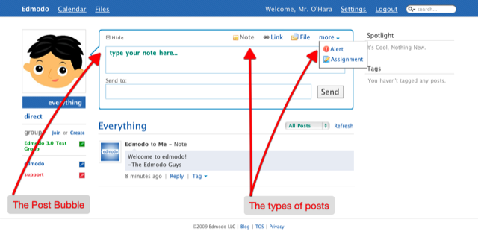
To post a note in Edmodo all you have to do is type your message in the message box, and then type a group, student name, or another teacher name in the "send to" box. When you are typing in the "send to" box, it will give you suggestions with what group or other users that you can send to.

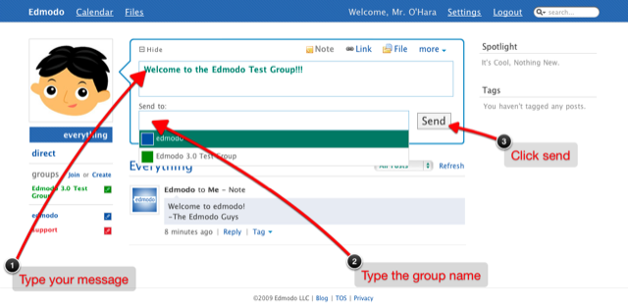

You also may type more than 1 group to send to multiple groups/classes.
This is what our first post looks like:

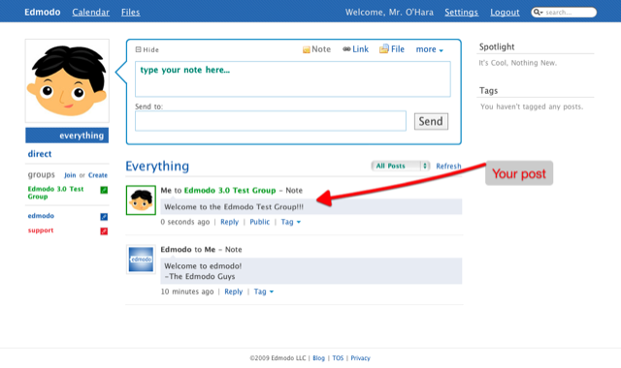

5. Replying to a post
Replying to a post is as simple as clicking the reply link below a post.
Type your message and click the reply button
This is what your post should look like with a reply. You will notice replies are now threaded underneath a post on Edmodo 3.0 which is a big change from Edmodo 2.0. This makes for much better organization and it's now easier to follow a conversation.
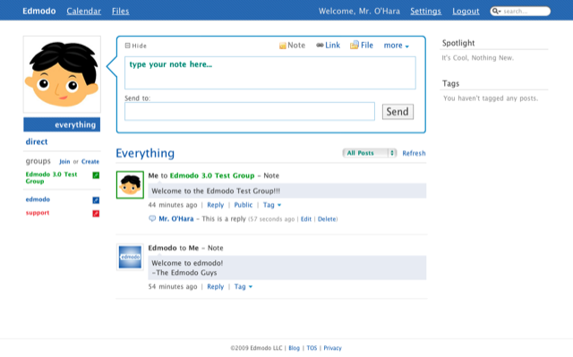

6. Post management
Here we outline what can be done with a post:
Anatomy of a post
The a post and it's replies are in the red box.
When you hover over a post you will see 3 blue boxes in the upper right corner of the post.
- The X is to delete a post - Teachers can delete any of their posts for groups they own or students posts, st iconudents can only delete their post
- The pencil icon is to edit a post - Teachers can edit any of theirs or students posts. Students can only edit their posts.
- The pop-out icon pops a window out of the browser for just that post and it's replies. Makes it easier to print if needed, but we frown upon wasting dead trees :)

Underneath the post you will see reply, public, and tag links.a
- Reply link - this is how you are your students reply to a post. In Edmodo 3.0 the replies are now directly under the original post for easier management.
- Public link - When you click this link it sends the post to the groups public timeline, if you click the pencil icon in the left sidebar next to the group, you will see a public link that takes you to the public timeline. Every post is private by default and only teachers have the option to make a post public.
- Tag link - click this to create tags for posts so you can sort them easily later. Tags are unique to each user and do not propagate down to other users.

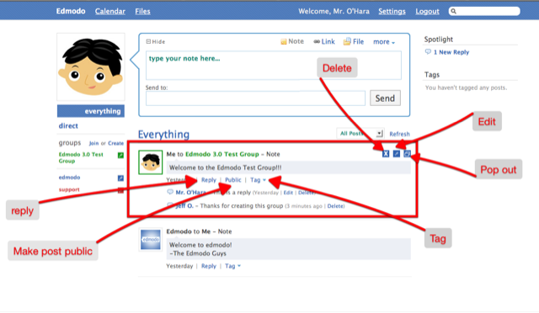

7. Group management
To manage your groups you can click the pencil icon next to your group. You get the following options
- Code & Info - This is the place you can retrieve your group code and change the code if need be. Use this If a code gets out and students join the group who are not supposed to be in the group. After you change the group code you can go to members and remove the student. You can also change the code after you know all your students are signed up effectively eliminating this from happening.
- Members - You can see a list of all your students in the group. If you mouse over a student you get more options
  - See a students grades
  - Change a students password if they forgot it
  - Remove a student from the group
- Feeds - Add an RSS feed that will automatically post to your group. This is great if you post video or pictures to another site such as Youtube, Flickr, Delicious, etc and want them automaticly posted to your Edmodo group.
- Public - This is a link to your public page if you choose to make any posts public. (remember everything is private by default and not sent here)
- Edit - Rename your group
- Archive - Click this to archive your group after a class has been completed. This essentially closes the group and can no longer make posts to it. Make sure you rename the group using edit before you do this if you want to use the group name again. We are working to automaticaly do this for you when you archive a group to save you a step.
- Change the color of your group
- Delete - Delete your group permamently- Currently Removed but will be make a return in the future.

8. Assignments and Grading
To post an assignment in Edmodo, click the more link in the post bubble and then click Assignment.
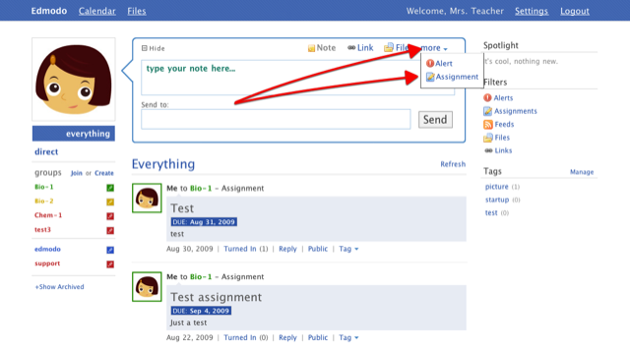

The post bubble should change to reflect an assigment post.
- Fill out the title of the assignment
- Describe the assignment
- Set your due date by clicking the calendar icon.
- You can add a file, but it is not required.
- Type 1 or more groups/classes in the send to field.
- Click Send

This is what a posted assignment should look like to the teacher.

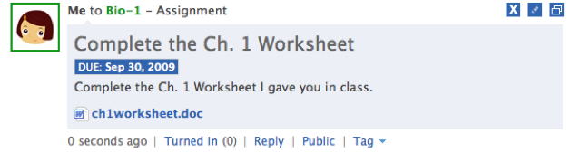

Turning in an assignment
This is what a posted assignment will look like to the student. Students should use the "Turn-In" link to turn their assignment. Replies should be reserved for discussion of the assigment as the whole group can see the the replies.

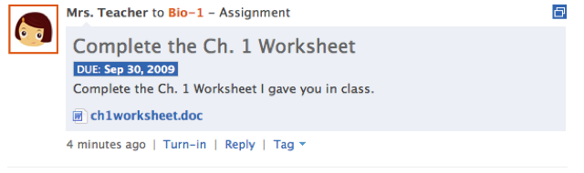
Students can either type a message in the assignment response box, and upload a file to turn-in their assignment.
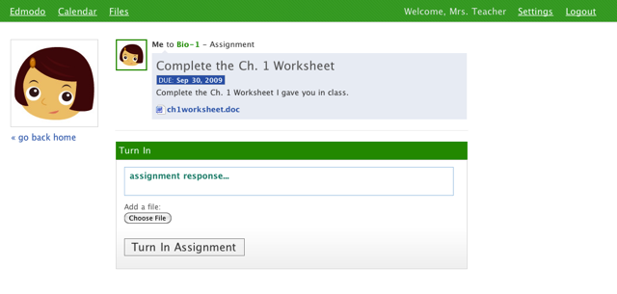

Grading an assignment
The spotlight area will show you how many assignments total that have been turned in that you need to grade. The assignment post will show how many assignments have been turned in for just that assignment.

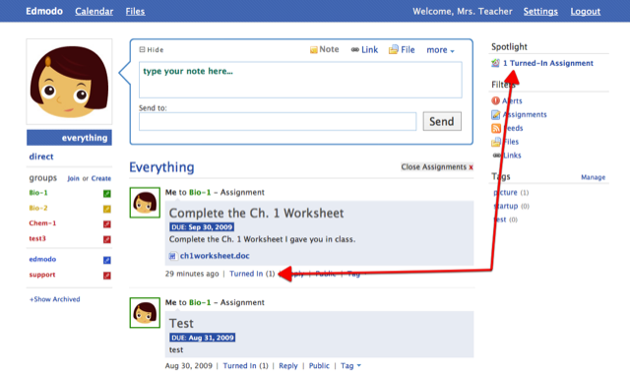

When you click the spotlight a turned in assignment will show a list of all turned in assignment that need a grade.

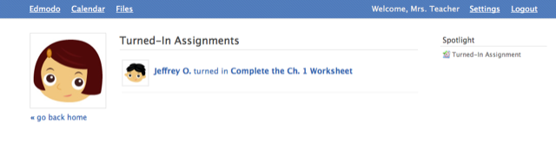
When you click a studentents assignment, you can review it by downloading the assignment and then by grading it. When you grade an assignment the student is immediately notified that they have received a grade.

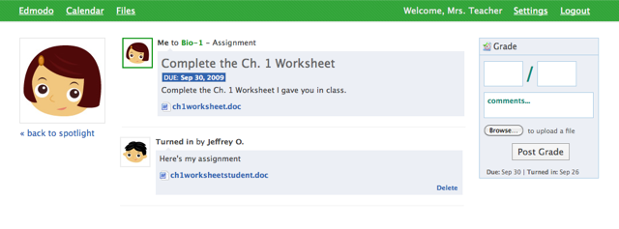

9. Settings
To get to the Edmodo settings page. Click the settings link in the upper right corner after you are logged into Edmodo.
The Edmodo settings page consists of 4 major blocks.
- User photo
- Notifications
- Personal information
- Password

User Photo
You can upload your own user photo or select from one of our 14 pre-existing photos.
Notifications
We currently offer 3 different notification methods
- E-mail - The e-mail used will be taken from your personal settings area automatically..
- Text messages - you must enter the phone number and select the Mobile provider you currently use. If your provider is not listed contact us and we will see if we can add your provider.
- Twitter - you must enter your username and be following the @edmodonotify user on twitter.
After you have selected you notification method you can choose what type of edmodo notification you want to be notified of.
- Alerts
- Links
- assignments
- Direct messages
- Notes
- Files
- Events
- Replies

10. Calendar
The calendar is a simple way to view your assignments in a calendar based format. Teachers can also add events to the calendar by clicking the day you want to add an event to, these events will show up on your students calendars also.

11. Public Pages
One thing we always want to stress with Edmodo is everything you post in your groups is private by default. We did however want to give teachers the option to make posts public on a case by case basis to share with the world. Every group you create has a public page
To get to your group's public page click the management icon next to the group, then click the "Public" link in the drop down menu.
Click the "Public" link on a post to make an item public.

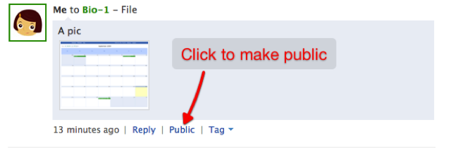

Click the red x to remove an item from your public page.
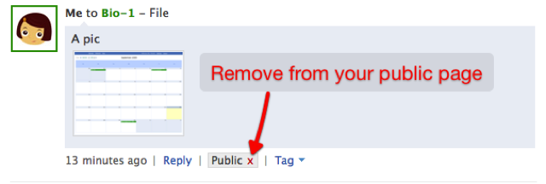
This is what your public page will look like. It has an RSS feed too.


